|  |  |  |  |  |
| --- | --- | --- | --- | --- |
|  |  | | | |
|  | |  | | |
| Project: | | Banking Management System | | |
| Team No.: | | 15 | | |
| Class: | | CSE 5324; Fall 2022 | | |
| Module: | | System Requirements Analysis (SRA) | | |
| Deliverable: | | SRA Document | | |
| **Version:** | | **[1.0]** | **Date:** | **[09/07/2022]** |

Contributors:

[List names of all team members, each on a separate line, centered]

Nirav Waghela - 1001919458

Pankaj Gope -

Deepak Lokande -

Abdul -

**Revision History**

| ***Version number*** | ***Date*** | ***Originator*** | ***Reason for change*** | ***High level description of changes*** |
| --- | --- | --- | --- | --- |
| 1.0 | mm/dd/yyyy | Name(s) | Initial draft |  |
| 1.1 | mm/dd/yyyy | Name(s) | Revision |  |
|  |  |  |  |  |
|  |  |  |  |  |

TABLE OF CONTENTS

**1. Introduction and Project Overview 3**

**2. Objectives 4**

2.1 BUSINESS Objectives 4

2.2 SYSTEM Objectives 4

**3. Project Context Diagram 5**

**4. Systems Requirements 6**

4.1 “Home Screen” Requirements 6

4.2 “Login” Requirements 6

4.3 “Search” Requirements 6

4.4 “Member Registration” Requirements 6

4.5 “Buy/Sell/Lend/Exchange” Requirements 6

4.6 “Form Club” Requirements 6

4.7 “Advertisement” Requirements 6

**5. Software Processes and Infrastructure 7**

5.1 Hardware and Infrastructure 7

5.2 UML Diagrams 7

5.3 Conceptual Data Model - Database 7

5.4 Screen Shots 7

5.5 Test Plan 7

**6. Assumptions and Constraints 8**

6.1 ASSUMPTIONS 8

6.2 CONSTRAINTS 8

6.3 Out of Scope material 8

**7. Delivery and Schedule 9**

**8. Stakeholder Approval Form 10**

**Appendix: 11**

# 1. Introduction and Project Overview

We are developing a banking system where a customer can open a savings / checking account using the system. The system will keep records of customers' all transactions including loans, debit cards, credit cards, etc. The system will also keep trac

# 2. Objectives

## 2.1 BUSINESS Objectives

The following is a list of business objectives:

**Objective 1**: Employee Registration: All Employees must provide the following information prior to using the system:

* First Name, Middle Name {Optional}, last Name
* Social Security number
* Home and mailing address
* E-mail address
* Mobile Number

**Objective 2**: Login functionality: All Employees must log in to the system with a user/password that was established during the Employee registration stage.

**Objective 3**: Dashboard consisting of various functions such as Branch Details, Customer Details, Loan details, and employee Details.

**Objective 4:** Branch Section will consist of all branch's details and employees can edit the details such as Brach Name, Branch City, and assets

**Objective 5:** Employees can create/view/edit the customer's savings/checking accountdetails which consist of following:

* Name
* SSN
* Address
* Assigned Employee
* account branch

**Objective 6:** Employee can view the customers' loan details such as Name, Loan Number, Loan Amount, Status of the loan

**Objective 7:** System consists of Account section which consists of Customer account details such as Name, SSN, Address, Savings

**Objective 8:** Banking application consists of Employee section where an employee can see the details of all other employees.

## 2.2 SYSTEM Objectives

The following is a list of system objectives:

**Objective 1**: The system will be a Web application

**Objective 2**: The system will be developed using

**Programming Lang**: C#,

**Framework** .Net Framework with MVC Design Pattern

**UI**: Razor View Engine (Razor Pages), Javascript, Ajax, Html 5, Css.

**Objective 3**: The application will be working on all the devices including iPad, mobile phones, etc, and will be responsive

**Objective 4**: MySQL will be used for storing Data.

# 3. Project Context Diagram

{Context diagram displaying all high level components goes here}

# 4. Systems Requirements

{Introduce the following requirement sections that correspond with the “user” functionality. Keep hardware, database, test data, and android versions to section 5. Add a new section for each category of your requirements. This is the heart of the SRA document, and hence the lengthiest, and should list all requirements of the system. **Please use the designated Requirements Form, and insert the forms below.**}

## 4.1 “Home Screen” Requirements

{List requirements}

## 4.2 “Login” Requirements

{List requirements}

## 4.3 “Search” Requirements

{List requirements}

## 4.4 “Member Registration” Requirements

{List requirements}

## 4.5 “Buy/Sell/Lend/Exchange” Requirements

{List requirements}

## 4.6 “Form Club” Requirements

{List requirements}

## 4.7 “Advertisement” Requirements

{List requirements}

**{Add as many sections as necessary, i.e. 4.8, 4.9 etc., each corresponding to a category of *user* functionality such as examples above.}**

# 5. Software Processes and Infrastructure

**Workflow: Waterfall Model.**

**Software Development Lifecycle Followed:**

The SDLC is classified as in the below layers:

1. Presentation/Application Layer

2. MVC Web Layer

3. Business Logic Layer

4. Repository Layer

5. Model Layer

6. Unit Testing Layer

SDLC has the following functionality in each layer:

1. Use 3-layer architecture.

2. Try to use 3-Tier architecture at production server.

3. Use Exception logging, create a log file on each exception.

5. Use unit testing, create unit testing.

## 5.1 Hardware and Infrastructure

Tools: Visual Studio 2022, My Sql, .Net Framework Packages, Entity Framework Package for Mysql.

## 5.2 UML Diagrams

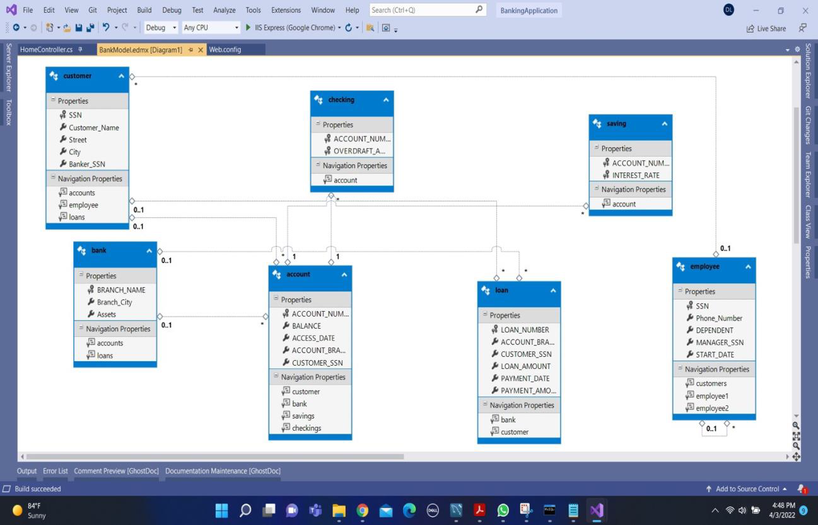

## 5.3 Conceptual Data Model - Database

{All database material goes here, if any}

## 5.4 Screen Shots

{Include any screen shots if you have any here. This may take several pages. If nothing available, mention “None available at this time”}

## 5.5 Test Plan

{Simply mention that a test plan will be provided at a later stage of the project}

# 6. Assumptions and Constraints

## 6.1 ASSUMPTIONS

The following is a list of assumptions:

* Ignore collecting money from external advertisements and general accounting
* Ignore compliance issues

## 6.2 CONSTRAINTS

The following is a list of constraints:

* Team lacks android experience
* Schedule very aggressive

## 6.3 Out of Scope material

The following is a list of “out of scope” material:

* Post Project maintenance is not covered

# 7. Delivery and Schedule

{List all tasks/milestones from start of the project to the end with specific dates for both Anticipated Start & End Dates

|  |  |  |  |  |
| --- | --- | --- | --- | --- |
| Task/Milestone Description | Anticipated Start Date | Anticipated End Date | Status | Comments |
| Prepare Requirements and UML diagram | 9/14/2018 | 9/29/2018 | In Progress | Deliverable will be UL document.  Increment 1 Deliverable |
| SRA document (Includes project objectives, Requirements and UML diagrams) | 10/3/2018 | 11/3/2018 | In Progress | Deliverable will be the SRA document. All stakeholders agree on the content of the SRA by signing in section 8.  Increment 2 Deliverable |
| Home screen design and implementation | 3/20/2018 | 3/20/2018 | To Be Completed (TBC) |  |
| Login and registration design and implementation | ? | ? | TBC |  |
| .  .  . | ? | ? | TBC |  |
| **…**  **List all required functionality and tasks**  **…** | ? | ? |  |  |
| Test case design | ? | 11/22/2018 |  | Increment 3 Deliverable |
| External Documentation (i.e. User Manual) | 11/25/2018 | 12/6/2018 |  |  |
| Project presentation | 11/29/2018 | 12/8/2018 |  |  |
| Final Milestone: project delivery |  | 12/8/2018 |  | Increment 4 Deliverable |

# 8. Stakeholder Approval Form

|  |  |  |  |
| --- | --- | --- | --- |
| Stakeholder Name | Stakeholder Role | Stakeholder Comments | Stakeholder Approval Signature and Date |
| Bahram Khalili | Development Mgr |  |  |
| Akshit Singhal | Project Assistant |  |  |
| {Team member Name} | Developer |  |  |
| {Team member Name} | Developer |  |  |
| {Team member Name} | Developer |  |  |
| {Team member Name} | Developer |  |  |

# Appendix:

{Additional documents or references, if any, go here. If nothing to place in this appendix, just write “None”, do not remove appendix}